Good morning, my name is Terry T. I am your Area Delegate on Panel 57. I attended the 2019 World Service Conference last month in Virginia Beach, VA.

The 2019 World Service Conference Theme was
Action is Attraction – There is No Growth in the Comfort Zone
L’action, c’est l’attrait – Il n’y a pas de croissance dans la zone de confort
La acción es atracción – No hay crecimiento en la zona de comodidad
Life is all about change. It is about our willingness to be open to this change—to use these opportunities for growth and to fall back on the Steps, Traditions and Concepts of Service to keep the program in check. Many Voices, One Journey (B-31), page 385

The purpose of the World Service Conference (WSC) is to be the guardian of Al-Anon’s world services, Al-Anon’s Twelve Traditions, and a service body, not a government. The World Service Conference is the voice of world wide Al-Anon. Concept Four: Participation is the key to harmony. Participants include Delegates from the US (including Puerto Rico), Canada, and Bermuda, WSO Volunteers and Staff, Chairman of the ECRPM, International Guests and Service Representatives. As a Delegate my purpose is to listen, participate, vote on matters affecting Al-Anon as a whole, and most importantly link our Area with WSC. (GR please read CARD #1 Spiritual Principals: trust, faith, gratitude, respect, unity, participation, goodwill, equality)

Board strategies & Mission Statement
Read Strategic Plan card
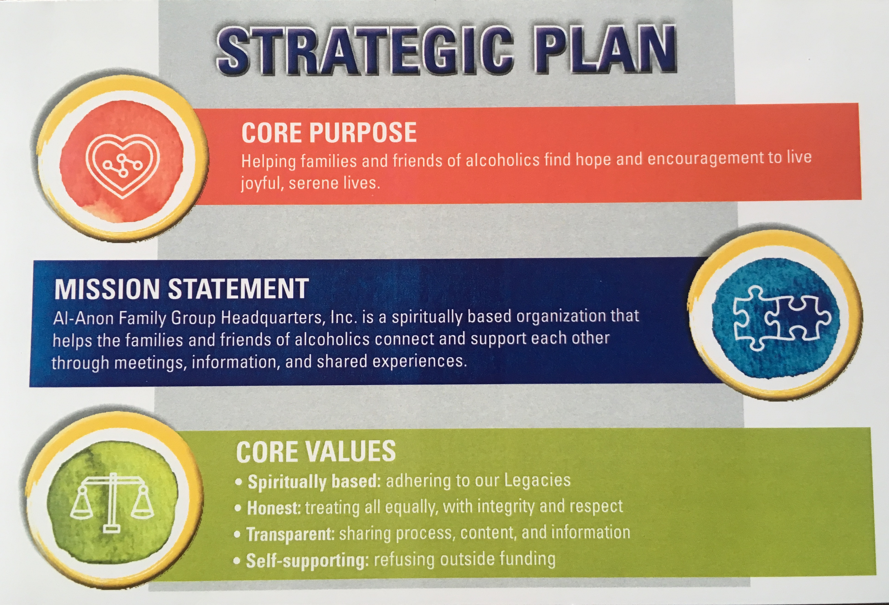

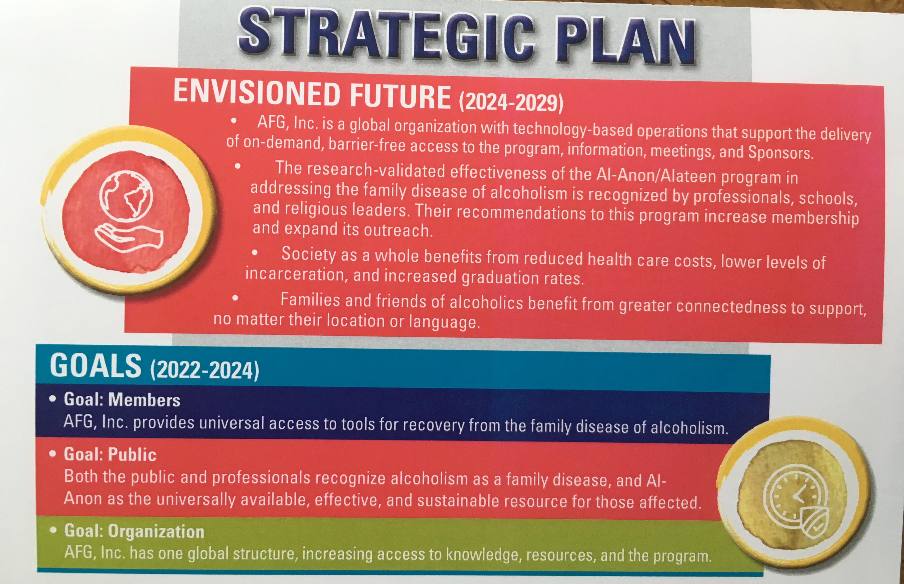

This year was the first WSC with simultaneous translations in French and Spanish. This is a three-year trial. Our first year was a huge success. There were French translators for the Quebec East and Quebec West Delegates and Spanish translators for the Puerto Rico Delegate and the International Representative from Mexico. We have several Trustees and Delegates who are bilingual and also appreciated the translators.

Here are a few ideas from other Areas: NM has set up an E-buddy system for GRs without email. SC is setting up displays in Municipal Library cases. University libraries might also be a good fit. Another Area has an Alanon/Alateen booth at a School Counselor’s Conference. Not sure if Alaska holds any of these. In Arkansas the Archives Coordinator and volunteers are conducting oral histories of long time members. These will remain in the Archives and can be listened to only at the archives facility. Minnesota South hosts a Folderol every third year. It’s a quasi-third assembly for new panel members to learn how to be GRs, DRs, Coordinators, Area service members to their responsibilities. The out-going panel members and the incoming panel members are provided an opportunity to exchange information/questions. It’s a weekend of fun, information, food and foolishness in the form of skits, crafts, and décor.

Chosen Agenda Items
The Board of Trustees presented the Chosen Agenda Item (CAI) regarding whether or not a group that has a period of meditation or quiet time as part of its format is following the Legacies. We were asked to consider:
- Does a group violate the Traditions when it includes meditation as part of its meeting format?
- Is holding a period of meditation as part of the meeting format an appropriate exercise of group autonomy through its group conscience?
- What can a group do to assist and advise newcomers should a group use meditation during their meeting?
After I share with you some of the thoughts Conference members expressed I am going to open the floor up for a brief discussion.

- Are we respecting Tradition 4? Each group should be autonomous….
- We don’t want newcomers to be turned off
- We don’t get to hear your Experience, Strength and Hope (ESH)
- We’d have a hard time with quiet time in my meeting, we can’t wait to talk!
- Is meditation “mutual aid?”
- How important is it? We have other more important issues
(GR please read CARD # 3: How important is it? This is not a hill I want to die for!)
- Slippery slope – let it run its’ course, may fade away
- Is meditation a religious belief?
- Is this following Tradition 1? Our common welfare should come first…
- Practice one to three minutes of meditation at meetings-many or most members are not from Christian backgrounds and they see one to three minutes of meditation is prayer for them
- As We Understood – good CAL for Step 11
- Concept 5 allows members to hold minority opinion
- Dec. 3 in Courage to Change has a good reading on meditation
- Opportunities to stop and meditate when some members lives are in chaos could be a lifesaver
- Meditation not “guided meditation”
- Group autonomy comes with responsibility
- This could create confusion
- New members may not hear ESH
- Tradition 2 - is it keeping with our group purpose?
- Step 11 encourages prayer and meditation but not necessarily in a meeting

Before I open the floor to discussion I will ask GR please read CARD # 4 Al-Anon is a Worldwide Fellowship, There’s always room for one more voice!

Discussion use big paper sticky notes

Policy Work Group Discussion-Electronic Meetings
Electronic Al-Anon meetings are thriving. As of Dec. 31, 2018 there were 214 registered electronic meetings with thousands of members. The online platforms that are currently in use are:
- Bulletin Board: 6 meetings in English, Russian, Italian, and Danish
- Chat: 12 meetings in English, Spanish, Farsi, and Polish
- Email: 27 meetings in English, Spanish, French, Estonian, German, Portuguese, and Russian
- Facebook Messenger: 3 meetings in English
- Free Conference Call App: An online platform: Members can call in or use the app to participate in meetings; 6 meetings in English have registered since January 1, 2019.
- Skype: 27 meetings in English, Spanish, Icelandic and Russian (of these 27 meetings, 18 are in Spanish!)
- Zoom: 2 meetings; 1 is bilingual Spanish/English and one is Danish

Since January 1, 19 new electronic meetings have registered; this is the most ever experienced.

For more information about electronic meetings (e.g., starting an electronic meeting) see page 32 in our Service Manual and the Al-Anon website. WSO had a conference call with the members with the Current Mailing Address (CMAs) of registered electronic meetings in Oct. 2018. About 30 CMAs participated.
- Electronic meetings do not have GRs, their CMAs are their direct link to WSO
- Electronic meetings are NOT connected to an Area or District
- Electronic meetings want more interaction with WSO
- Electronic meetings can meet needs of members who cannot go to physical meeting
- Today people want 24 hours access to electronic meetings
- Electronic meetings have same issues as face to face meetings
- Many EM members are long time Al-Anon members
- Anonymity in electronic meetings: same trust needed as face to face
- G-39 CAL is the Al-Anon Electronic Meeting guideline
- The Electronic Meeting Registration Form has been updated
- Out of this conversation an AFG Connects Community for electronic meetings was created and went live Jan 2019

Anonymity using Facebook
Three kinds of Facebook A-Anon meetings:
  - Closed: content only visible to group
  - Secret: can only be joined by invitation, content only visible to group
  - Messenger meeting: similar to secret meeting

WSO/Vallie will be sending letters to Electronic Meetings with an invitation to register and letting them know that we want to work with them. If they do not register we will ask them to cease using the Al-Anon name-this is to protect our name and trademark.

The place to find a “registered” Al-Anon meeting is through our Al-Anon website NOT Google!!!!*****
GR please read CARD # 2: TTWWADI HAT: That’s The Way We’ve Always Done It

One of my favorite parts of Conference is hearing the Staff Reports.
New PSAs:
We have learned from our PSA vendor that our message was not resonating well. So this year, we are going to test this feedback by presenting two different PSA versions. Both versions were designed with a broad appeal. One version was built using the previous formats featuring a 40-something white female concerned about their spouse's drinking (which is aligned with the most common newcomer demographic according to the 2018 Membership Survey). We refer to this version as the Champion. The other version poses questions and presents a wider range of images to display our diversity. This version is referred to as the Challenger. Both versions have different phone numbers and special web addresses to allow us to tell which version is more successful in generating visits to our websites and calls to our toll-free meeting line.
They will be available in English, French and Spanish and :15, :30, and :60 minute versions. These new PSAs will be available in August. Here’s a preview! (Al-Anon\Delegate\Report\PSAs or Desktop or thumbdrive)

Scot P., Associate Director—Digital Strategy
The Digital Strategy Team is working hard to find new ways of communicating and to improve upon existing methods of communication so that our message can reach every person, from the young to the young-at-heart. They continue to share Al-Anon’s message of help and hope through social media and have been testing paid ads—the equivalent of online billboards—to raise awareness.

Last year was a record-breaking year for the Al-Anon website, with over 3.5 million visits to al-anon.org and over 1.4 million people finding meetings using our online meeting search. For the last two years, we have achieved our one millionth visit at the end of April, but this year we hit 1 million visits a full month earlier, with over 60% of the visits coming from first-time visitors to al-anon.org. These visits have led to over 540,000 meeting searches. At this pace, we can expect to have over four million visits and two million meeting searches in 2019.

The Digital Strategy Team is responsible for public outreach and communications with the media. Face the Truth is a relatively new show on CBS, created by the producers of The Doctors. The shows’ producers have requested (and WSO Staff have permitted them) to display the Al-Anon logo during four episodes so far, including most recently for a taping in February. The show starts with an intervention in which family members and friends encourage the alcoholic to “face the truth.” Afterward the co-host recommends that the family members attend Al-Anon and Alateen.

The Digital Strategy Team is responsible for keeping our website looking fresh and inviting, by posting current and relevant content and by growing our In the Loop subscriber list. How many of you are receiving IN THE LOOP in your e-mail? If not, go to our WSO website al-anon.org, click on Members and you will see on the middle of the page “subscribe to IN THE LOOP” Just type in your e-mail, select your country and your language (English, Spanish, or French) and you’re done! Next month, you will get information directly from the World Service Office! Here’s a good idea: have a group e-mail list that you could forward IN THE LOOP to everyone in your group?

Last but not least, the Digital Strategy Team has kicked off a project to develop an official Al-Anon mobile app, which they plan to make available later this year.

Literature:
Al-Anon's newest piece of Conference Approved Literature, Just for Tonight Bookmark (M-81) is now available in English, French, and Spanish. This new companion piece to Al-Anon's classic Just for Today Bookmark (M-12) is based on a popular article from The Forum. Just for Tonight offers thoughtful reflections on Al-Anon principles to help us slow down and prepare for a peaceful, restful night. It is now available for 10 cents each. This piece of literature was developed by request from our members that liked a Forum article and asked that it be considered to be made into a bookmark or separate piece of literature. WSO listens to us!!!!

AFA can now be ordered all year round! The WSO will ship AFA 2019 magazine orders as received while supplies last. See In the Loop May 1st
In March the WSO posted 20 quotations for use in 2020 calendars on the Announcements community of AFG Connects. Pass around calendar examples
Nine proposals from Al-Anon members who are professional writers/editors who want to work on the NEW DAILY READER (working title) were received. Staff is currently reviewing the proposals.
In May and June “Inside Al-Anon Family Groups” articles in The Forum will focus, consecutively, on how CAL is developed and the procedure for discontinuing CAL.

I asked them to take into consideration the delayed delivery of issues when including date sensitive information

International Activity
Outside of the United States, Canada, Puerto Rico and Bermuda Al-Anon has 36 General Service Offices (GSOs) and 14 Service Boards. There are local meeting contacts in 68 other countries where Al-Anon has a presence.

Group Services:
The Chosen Agenda Items from past WSCs was indexed and posted to AFG Connects last month. It includes links to the appropriate WSC Summary (hold up a Conference Summary)

“Let’s Talk about Safety in Al-Anon Meetings!” service tool has been extremely well received. This service tool is now posted in English, Spanish, and French on the al-anon.org website. It can be found on the Group Resources home page.

2019 marks the 55th anniversary of the Alateen Talks newsletter and the 18th anniversary of the daily reader Living Today in Alateen (B-26). Alateen literature is Al-Anon literature. Consider having a discussion in your Al-Anon meetings about using Alateen literature. It may provide a different perspective on how Al-Anon members can support Alateen.

GR please read CARD #7: High Will, High Skill, Over Thinker, Overachiever!

Financial Report
I have shared with you how our WSO spent last year investing their time and talent to support our members and reaching out to potential members worldwide. Reaching our goals is only possible because of the financial contributions its members make. These contributions allow our WSO trusted servants to provide services that keep our fellowship unified and thinking about our future while carrying the message of hope and help throughout the world.

Page 215 of the Service Manual reads, “The certain and continuous solvency of our world services rests squarely upon these contributions”.
It has been said that “healthy relationships have discussions about money”…….so let’s start talking!!

Strong literature sales in 2018 were related to the introduction of new literature: The pamphlet Hope and Understanding for Parents and Grandparents, the book Intimacy in Alcoholic Relationships, and, the ODAT 50th Anniversary Edition. Who has gotten one or more of these new publications?

Our Investments were down due to Market volitility. The oversight of our investments is taken very seriously. The Finance Committee and Board of Trustees meet with our fund managers on a regular basis to maintain moderate risk.

The international convention made a profit.

Let’s celebrate - our 2018 Contributions exceeded $1,950,000 for the 3rd year! Wahoo!
Thank you and your groups for your contributions and a special thank you to all the groups who donated memorial gifts marking the 30th Anniversary of Lois’ death last year.

Let’s take a look at the handout I gave you, titled 2018 Structure Contributions. It’s a wealth of information. If you look at the top left hand side you will see how our Area contributed to WSO services. Area 63, Alaska, contributed $7,804 in 2017 and $5,794 in 2018. On the handout you will see that 68.4% of our Area’s groups contributed which is over 10% more than last year. The average per group was $207.13 in 2018, while in 2017 our average was $255.54. Interesting…..I’m very proud that more Alaska groups are sending in contributions.

At the bottom right-hand side of the page are the overall totals. Below that in the box is the Estimated cost of service provided overall of $4,254,541. Also in the box is the estimated cost of services provided per group, which is $292.39. Turn over the page and you will see how WSO calculates this number. How’re we doing? Are we paying our way? Not quite!

Although our contributions were down, I’m still very proud of our Area. You can see that we, Area 63 Alaska, isn’t too far off the mark. If you look down the list there are very few Areas contributing over $200 per group. Way to go ALASKA!!!!

Next time that 7th Tradition basket comes around; think about how much the WSO does for you as an individual, your group, your district, and our Area. If you or your group members ever wonder what is it that WSO does for your group, I suggest you look on the back of the Quarterly Appeal to Members letter and you will see a list of services provided. Also keep in mind this bit of trivia: Adjusted for inflation, $1.00 in 1965 is equal to $8.05 in 2019, which is 15 cents more than last year! Or 31 cents more since I became Delegate three years ago!

Can you spare another dollar or two? If each group that contributed last year upped their contribution by $8 we could reach our 2019 budget goal!

2018 Expenses from Operations
Overall these expenses remained about the same the 2017 expenses.

Some 2019 Budget Highlights
Revenue budget is $5.3 million…
Literature Sales will decrease because of no new major publications
Contributions budget is slightly higher than 2018
Did you know……. $20 in literature sales is not the same as a $20 personal contribution? Unlike literature sales, personal contributions do not have overhead. Because of that, these donations give our WSO trusted servants more options.

The Expense budget is $5.5 million seeing increases in Labor Costs and Travel and Meetings (6 TEAM Events in 2019)

Strategic Planning initiatives are budgeted at $54.5 thousand.
These initiatives include development of a mobile App, translation software, hiring a part-time Spanish editor

This leaves us with a projected budget deficient of almost $180 thousand

In case you are wondering, we can have a deficit; page 206 of the service manual states
“This (Finance) Committee may be compelled to risk temporary deficits.”

A deficit is a plan which revenue is less than expenses. The Finance Committee did not make the decision lightly to submit a deficit budget. The WSC approved the deficit budget because we are moving forward to meet our goals and mission. It is a challenge we can take on! Remember if every group donated $8 more than they did last year, it would help us reach our goals. That’s an additional 15.38 cents per week!

Things to take back to the groups and use for discussions:
Share with members the Spiritual Principals of Al-Anon’s self support such as abundance, gratitude, and responsibility. Pages 101-102 of the service manual

Share these Excerpts from Warranty One from the service manual. Page 213 talks about sufficient operating funds:
Our attitude toward giving time, compared with giving money, presents an interesting contrast. We give much time to Al-Anon activities for the sake of our groups….
But when it comes to the spending of cash for Al-Anon service overhead, many of us turn reluctant.

When we drop money in the meeting basket, its usefulness is not as obvious as when we talk to a newcomer.
When each member can be shown how much the service dollar really buys in terms of helping families to find Al-Anon, contributions are willing and generous.

It is our responsibility as service representatives to show members what our contributions do in helping families and friends of Alcoholics.

To help us fulfill our mission, 2019 is filled with two new PSAs, software systems that allow our WSO to be more efficient and collaborative and technology that will support members and potential members.

Does anyone have any questions? If anyone wants to see the audit report or detailed budget slides, I have lots and will be happy to provide them to you! Talk with me during a break.

GR please read CARD #5: HP loves you! I came into this program kicking and screaming and holding my halo!

Welcoming Potential Members
There was a Thought Force Presentation on Welcoming Potential Members. I hope everyone received this handout. There’s lots of good ideas here. It’s a great resource. Please share it with your members. I’m sorry time does not allow me to go over it today, however take some time to review it and any questions you have can be written on posted notes and placed on the poster board for either answering when we have time, or answers will be sent out in a separate email.

GR please read CARD # 5: Outreach idea to newcomers, put your name and phone number on the back of a Serenity Prayer Card or the new Just for Tonight bookmark.

World Service Handbook Updates
Next I’m going to talk about some World Service Handbook Updates (hold up Service Manual). When we review and vote on these changes we keep in mind the following questions:
1. Is it clear & accurate?
2. Is it consistent with our spiritual values?
3. Can you live with it?

We reviewed and voted on some Alateen language revisions for the “Alateen Policy” section of the “Digest of Al-Anon and Alateen Policies” (Policy Digest), on pages 93–97 of the 2018-2021 Al-Anon/Alateen Service Manual (P-24/27). The Policy Committee, adopted by the Board of Trustees, recommended these changes. The revised language includes information that was not previously provided, greater clarity in wording, and more logically ordered subsections. Additionally, it more fully explains the basis of the policy, while providing the spiritual principles that underlie the policy. The intent of this revision is to help readers find the guidance they seek when consulting the Policy Digest for Alateen information.

The second CAI we discussed in breakout groups. The topic was Electronic/Virtual (Business) Meetings. How can we step out of our comfort zone-in this case face-to-face District and Area business meetings-and incorporate electronic participation?
- Why this “Electronic/Virtual Meetings” CAI is important:
  - Currently we have face-to-face District and Area business meetings. Allowing for participation through electronic media might increase participation in District and Area meetings and bring large geographical or rural areas together
  - Should we establish protocols for handling business meetings (e.g., roll call, voting procedures) that include GRs that participate by voice call or other electronic media?
At first I thought, I got this- we already have District and Area telephonic meetings. Here are some good ideas I gained from our discussions:
CONS
- Fear of change does exists
- When on a conference call there can be many distractions
- Loss of networking
- Loss of level of commitment
- Is it possible to have heartfelt connections virtually - Attraction and Action leads to meet face to face

PROS
- Teleconference would allow all to be present
- Overcomes distance and weather challenges
- Bring balance between connection and isolation
- Conference call can revitalize Groups and Districts that dropped involvement in District and Area respectively
Things to Consider/Ideas
- Some Areas are already using tele-conferencing
- Some Area business meetings, Task and Thought Force meetings are using Web Ex or teleconferencing
- Used in medical & legal fields – what can we learn from this?
- Shared resources (we don’t have to reinvent the wheel)
- Use reserve dollars to pay for a program/software; start with AWSC, sign up for it then share with Districts
- Ask Area/District to consider video call
- Research what resources (i.e., teleconference/videoconference/webinars) are available
- Setting up protocols, use links of service
- Use Task Forces
- Use KBDM
- What’s the motivation for it?
- Shared resources and training
  - *Florida N has webinars of trainings on their website: Intros to IT Software use
  - There is help available on how to set up the position of Technology Coordinator
- Small steps, implement tech plan using incremental steps
- Elements could be virtual: e.g., New GR Orientation post as webinar and have available to view before Assemblies
- Have patience
- How do we encourage more participation?
- Use the Three As
- Sending agenda prior to call is vital
Open Discussion

SAVE THESE DATES!
Road Trip! 2019 will be the sixth year the Board of Trustees has taken to The Road. After a week of board meetings the Trustees and members have a full fun day of fellowship. This is an opportunity for members, Trustees and the Executive Committee to interact with each other. Some comments from last year’s Road Trip in Houston, TX:
- Road Trip demystifies WHAT Trustees do.
- Because of the unconditional love I receive in Al-Anon I am able to give back unconditionally.
- Service is not a chore; it is a lot of fun and it fosters great spiritual growth.
- Road Trip! Is like Al-Anon on steroids.
I am very excited to announce that Road Trip! 2019 will be Sunday, October 20 in Seattle WA!!!! Registration is not open yet, stay tuned!

If we want to host a Road Trip! Deadline to apply is Oct. 1, 2019. One of the requirements is that an Area expects a minimum of 100 attendees. Not sure we could pull that off.

The next Al-Anon International Convention will be June 29-July 2, 2023 in Albuquerque NM ****SAVE THE DATE****

The 2020 AA International Convention – 85th Anniversary will be in Detroit, MI July 2-5, 2020. In keeping with Tradition 6 I hope you will consider attending.

TEAM events –There are five upcoming TEAM events this year. They will take place in Maritime Provinces and Quebec in May, New York (S) and South Carolina in June and Pennsylvania in September. These will be the last TEAM events. The Board of Trustees has decided to end TEAM events. What’s next? The Board of Trustees will present Vision 2020 at the next WSC. It has been recognized that TEAM events escalated service in Areas with TEAM Events.

2020 World Service Conference will be April 20-24, 2020.

GR please read CARD #6: Opportunities for service offer members use of their talents in different stages of recovery

I am excited to be on the Task Force: Reaching and Unifying Rural and Large Geographic Populations. We will be meeting virtually throughout the year. I hope to have more to share with you on this topic at the Fall Assembly.

Does anyone have any questions?

I was quite humbled and honored last December when I was invited to be one of the three Spiritual Speakers at Conference this year. Of course I wondered, “Me? Really? Why me?” and at conference I heard the answer from Angela Doyle the Delegate from Newfoundland when she gave her three minute talk. She said: “I wasn’t asked to speak because I was better. I was asked to speak because I needed to grow.”
I want to thank everyone here for this amazing opportunity you have given me to grow these past two and a half years. I still have six more months, so I’m not done growing yet! It was definitely not in my comfort zone! I am very grateful to be your Delegate and I could not have done it without all of your love and support.

I also want to share that along with all the business of Al-Anon at Conference there is fellowship and friendships forged. We also have a lot of fun. Every year after Conference is officially over the outgoing Panel does a little informal off-the-record skit. Panel 57 has some theatrical members and so we went a bit “over the top” and came up with The Wizard of Al-Anon Oz! I was the Cowardly Lion. Our Area’s Alateen inspired one of the Munchkin’s lines when they were telling Dorothy about how awful the drunk Wicked Witch of the West was:
She took away our crunchies
And she took away our munchies
And then she took away our peanut butter and now we don’t have any peanut butter for our Alateen meetings!

It was a blast and a much needed release after our week of work. I’ll try to have some highlights to share with you in the fall on our production. Here’s the brief video we started with: play Beneath Al-Anon Skies (desktop & thumb drive)

Thank you very much and thank you everyone for your service to Alaska Al-Anon!

